

EE 513

THEORY AND DESIGN

OF

ELECTRONIC POWER SUPPLIES

REPORT OF TERM PROJECT

“MULTI-OUTPUT FLYBACK DESIGN”

Abdurrahman Aydın

Table of Contents

Introduction 3

Design Decisions 3

Comparison of Different Topologies 3

1) Single Phase Thyristor Rectifier 3

2) Three Phase Thyristor Rectifier 3

3) Three Phase Diode Rectifier + Buck Converter 3

Design 4

Component Selection 5

Full Bridge Rectifier 5

Power MOSFET 5

TLP250 (photocoupler)[4] 6

Freewheeling Diode 6

DC Link Capacitor 6

Buck Converter Inductor 6

Buck Converter Capacitor 6

Computer Simulation 7

R-Load Simulation Results 7

Running Motor at No Load Simulation Results 11

1)For Duty Cycle of 0.9 11

2)For Duty Cycle of 0.5 12

3)For Duty Cycle of 0.1 13

Tests Results 15

Component Tests 15

1)Inductor 15

2)TLP250 Tests (Duty Cycle and PWM) 16

R Load Tests 19

Motor Tests 21

Conclusion 25

References 26

# Introduction**

In this report includes five main parts. These parts are as follow;

* theoretical information about converter,
* Design process (calculations, element selections, design of power circuit (rectifier and DC-DC converter) and magnetic elements.)
* simulations,
* theoretical calculations and comparison of simulation results,
* evaluation and conclusion

# Theoretical Information

The system of AC-DC converter includes basically two parts. These are

-PFC part

-Fly back converter part

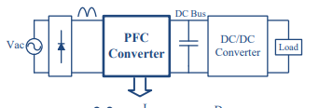

PFC

PFC is used for conversion of an alternating current to direct current and producing continuous current by power supply. For converting AC current to DC current, four diodes are used as seen from figure 1. Also, output side of the diodes are shown figure 2. For taking pure DC voltage and doing power factor correction, boost converter is used. Boost converter is most ideal converter for power factor correction.

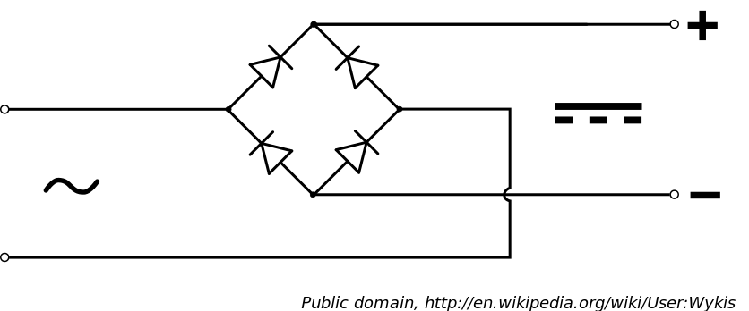

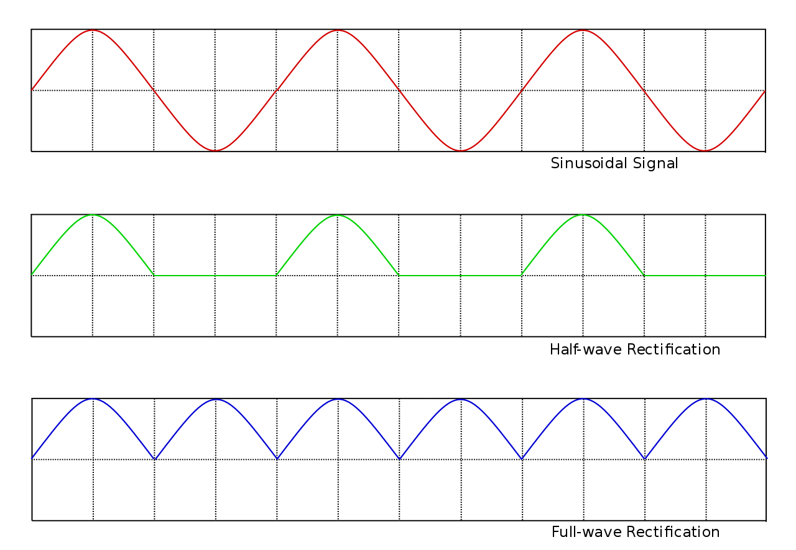

The PFC circuit and output simulation are shown figure 3. Input voltage and current according to mode is given figure 4.

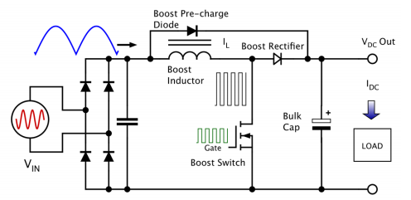

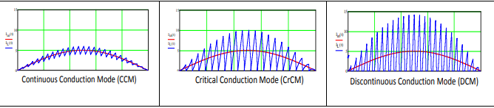

Ripple voltage changes according to size of capacitor and inductor. İnductor value are chosen according to output voltage and desiring ripple of output side. Inductance of PFC’s inductor is calculated as follows;



Maximum current on inductor is calculated as follows;



Inductor consist of two part copper and core. When we design inductor, we consider these two material features. Then, we have to choose most proper material for minimizing power loss. Power loss are defined as:

**Inductor copper loss is calculated as follows;**





**Inductor core losses are calculated as follows;**







a,b,c,d are parameter of core selected by us;

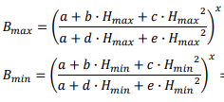



The AC flux swing at the peak of the line cycle is:





Average core loss across the line cycle is:



In addition MOSFET loss I also important. MOSFET is chosen according to Rds, frequency and maximum voltage capacity.

Total MOSFET loss is calculated as follows:



Conduction mode loss formula is this:

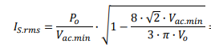



Turn on loss calculation is as follows;







Turn off loss calculation is as follows;





Output capacitance switching loss is defined as;



Gate drive loss is defined as:



Boost diode selection:

One of the most important thing of designing boost converter is selecting proper diode for our system. Since, Boost diode cause the biggest part of energy loss of our system. Therefore, when we choose boost diode we consider open voltage of boost diode and maximum voltage of diode. In addition switching loss of diode is a big problem for us.

The loss calculation of switching loss and conduction loss are as follows;





Total loss on boost diode is;



**Output capacitor selection;**

Output capacitor size changes according to desired ripple of output voltage. If desired ripple voltage is small, Capacitance has to be high as possible. To contrary, desired ripple is not important, we can use small capacitance.

Capacitance calculation of output capacitor is defined as follows;



Hold up time is changes according to supply frequency.



Capacitance have to obey these two conditions.

Capacitor ESR loss is calculated as follows;



Capacitor rms current defined as;

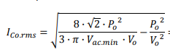

Power loss is:



Fly-back Converter

Fly-back converter is basically thought as isolated buck-boost converter. Different from basic fly-back converter we used multi output transformer for construct two different output voltage. The circuit of fly-back converter is given as follows;

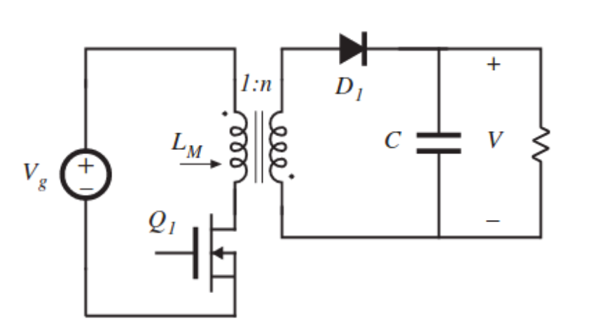

The output voltage of converter is calculated assuming diodes are ideal as follows;

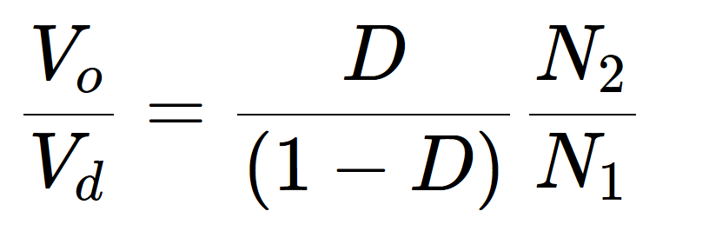

The fly-back converter designed by us consists of 3 main parts.

* Controller
* Transformer
* Snubber and MOSFET

First part is transformer part. Transformer is using for isolation and increasing or decreasing coming voltage and current primary side. Second part is snubber. Snubber is used for decreasing voltage on MOSFET. Effects of snubber on circuit will be determined at snubber part. Last part is controller part. Controller is used for working on load types or different input voltages.

The sub-parts are given as follows;

Controller

Controller is used to receive constant output voltage without affecting the input voltage. Therefore, before selecting controller, we have to consider these things;

* Voltage on MOSFET
* Switching frequency
* Consuming maximum energy on controller.
* Maximum duty cycle
* Maximum output power

We have to consider that whether our controller fixed frequency or not. Voltage o MOSFET very important if our MOSFET voltage is integrated in controller.

Therefore, when we choose controller, we have to fore see these conditions.

Transformer

Transformer is used for isolation and changing voltage range. When designing transformer, the important things are

* Core size and type,
* Inductance of primary and secondary sides
* Thickness and type of cable used
* Turn ratios of two sides

For determining transformer’s parameter, we consider following things,

Core size and type are determined according to Pout range. For fly-back converter, we choose EE type core. There are different material if we want to choose.

When designing transformer, we have to consider two voltage Vreflected and Vinmin. Determine Dmax based on Vreflected and Vinmin: The maximum duty cycle will appear during VDCmin, at this condition we will design the transformer to be at the boundary of DCM and CCM. In our design, we want to stay DCM side. Therefore, the given calculations and equations are according to DCM mode. Duty cycle here is given by;



The calculation of primary inductance and primary peak current are as follows;

The primary peak current can be found by using following equations:







After calculating primary inductance, core type, turn ratio and copper weight are calculated.

When choosing core, these are considered as follows;

* core geometry
* core size
* core material

There are different types of core geometry such as ETD, EE, etc. Most of the flyback application EE types are chosen.

Core size changes according to maximum power of transformer. Therefore, when output power increases, core size also increases. Core size is chosen according to datasheet of cores.

Minimum turn ratio is defined according to given formulas;



Determine the number of turns for the secondary main output (Ns) and other auxiliary turns (Naux): To get the secondary turns first determine the turn ratio as “n“;





Determining the wire size for each output windings: In order to determine the required wire size the RMS current for each winding should be determined. Primary winding RMS current:



Secondary Winding RMS current:



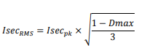

Snubber and MOSFET

In the project, switching device is MOSFET. In the real life, used transformer is not ideal. This situation causes leakage inductance on the transformer. This can be called inductive load as well. When inductive load is used and switching is made, inductive current is cut suddenly. This sudden cut causes sharp voltage drop on MOSFET.

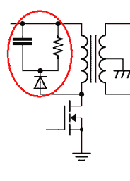

*Schematic of snubber circuit*

To prevent this sharp voltage drop, snubber circuits are used. Snubber circuit provides path for inductive current and prevent to sudden cut on the inductive load. This implies that sudden voltage drop on MOSFET does not occur. As seen from figure we can use capacitor, resistor and diodes. Also, if we do not have suitable area on our board, we can use zener and diode as snubber too.( Zener placed at capacitor and resistor area I used zener in y)

When we choose MOSFET, we consider following things;

* Rds resistance of MOSFET
* Max frequency of MOSFET
* MAX capacity of voltage

After determining these values, we can choose our capacitor at least %10 higher than these values.

**Design Process**

|  |  |
| --- | --- |
| Input Voltage | 90 – 250 V rms AC, 50 Hz |
| Outputs | 1) 12 V, 100 W max.  2) 5 V, 10 W max. |
| Output Ripple (max): | % 4 |
| No Load Power(maks) | 100 mW |
| Conduction Mode | DCM |
| Efficiency | min 85% |
| Topology | Flyback |
| Switching freq. | 100 kHz |
| Input Side | PFC Boost Converter |

## Calculations and Magnetic Elements Design

**PFC design for our system;**

We design PFC according to “Theoretical Information” part. We have to define inductor and capacitor size according to desired ripple and given informations.

Firstly, PFC specifications are defined as;

Input voltage: 90-250 Vrms AC,50 hz

Output Voltage: 400V

Maximum Power: 130W for **%85 efficiency**

Switching Frequency: 100 kHz

Inductor Current Ripple: 25%

Output Voltage 100 Hz ripple: 10 Vp-p

Let’s start to calculations;

**For inductor**, the calculation is follows as defined theory part;



Ripple=%25=0.25

𝑉𝑎𝑐 𝑚𝑖n=90V

f=100 kHz

Vo=400V

Po=130W

**L=1.69 mH**

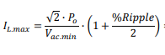

IL,max =2.29A .Therefore, inductor saturation current bigger than 2.29 A.

**Copper Loss:**





IL,rms =1.44 A

We assume DCR around 0.2 ohm. Since, product which used commonly industry “Kool Mμ” 77083A7 toroids cores from Magnetics Inc. has 0.07 ohm for 0.68 mH inductor. I plan to use 3 inductor series. Therefore copper loss is as follows;

PL,cond =0.4W

**Core Loss:**

In order to calculate the core loss, we must calculate the minimum and maximum inductor current and the associated minimum and maximum magnetic force (H), then we can use the fitted equation of that magnetic material to calculate the minimum and maximum magnetic flux (B). I decided using Kool Mμ 77083A7 toroids.

Specifications are as follows;

𝑃𝑎𝑡ℎ 𝑙𝑒𝑛𝑔𝑡ℎ 𝑙𝑒 = 98.4 𝑚𝑚

𝐶𝑟𝑜𝑠𝑠 𝑠𝑒𝑐𝑡𝑖𝑜𝑛 𝑎𝑟𝑒𝑎 𝐴𝑒 = 2 ∙ 107 𝑚𝑚2

𝑉𝑜𝑙𝑢𝑚𝑒 𝑉𝑒 = 2 ∙ 10600 𝑚𝑚3

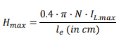

Hmax=186 Oersteds



=1.787



=145.5 Oersteds

Flux density for 60μ Koolu material is:



Where a = 1.658e-2 b = 1.831e-3 c = 4.621e-3 d = 4.7e-3 e = 3.833e-5 x = 0.5

We can find maximum and minimum flux density according to H-max and H-min

Bmax= 8.52 kGauss

Bmin= 8.03 kGauss



=0.245 kGauss

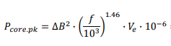



= 1.03*3=3W

**Rectifier Bridge Loss:**

For calculating maximum loss, I choose min input voltage at input side for



=1.3A

I change Vf as 1V. Therefore;



=2.6W

**MOSFET loss:**

I found that 45 mΩ CoolMOS™ C7 “IPW65R045C7” is the optimum device for my design because of low resistance and max frequency.

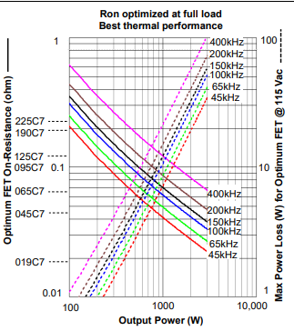

Switching loss is very low for 100 kHz for the selected MOSFET.



Therefore, we take 0.06 W for our system. Since, Rds=0.045 ohm and average current is equal to 1.4 A. There, we can neglect switching loss.

## Element Selection

#### PFC Element Selections:

**Rectifier Diode Selection:**

When selecting diode most important things for my system are as follows:

* Break Voltage
* Forward Voltage
* Maximum Frequency

I used two GSIB2580 diode packets for my system because of high break voltage range.

Forward voltage is around 1V.

**Inductor selection:**

When choosing inductor, we consider;

* Inductance
* Resistance
* Maximum energy capacity.
* Max current.

Inductance is around 1.7 mH for my system. Therefore, I used three “Kool Mμ” 77083A7 toroid’s cores from Magnetics Inc. has 0.07 ohm for 0.68 mH inductor.

**MOSFET selection:**

Important things for selecting MOSFET are

* Voltage capacity
* Max freq
* Rds

According to these parameter. I chose proper MOSFET for my system. The MOSFET called “IPW65R045C7” with 0.045 ohm Rds.

# Conclusion

In this hardware project, we observed AC to DC flyback converter with controller. The speed is adjusted according to DC output of our setup. We observed simulation results and calculation results are similar but not same. Also, we learned that using material is very important for project. Moreover, we learned that we do not trust calculations totally. Since,. We should search correct component for our system otherwise we can encounter some problems such as shorting(MOSFET drain to source) or burning our components. In addition, we did not observe any problem theoretically or on simulation works. However, we can encounter some problems in practical. Therefore, we have to test our setup again and again for taking better results and understanding the behavior of the components. Also, we observed switching loss is big problem for our system. Since, switching loss cause to increase temperature of our components. Therefore, we have to control that frequency is not very high such as higher than 15 kHz. To illustrate, when we tried to run the motor at full load with the system frequency of 31250 Hz, MOSFET’s temperature increased to 250 °C after 30 seconds. In addition, we observed parasitic effect on our setup. The cable can affect the system as capacitive or inductive because of length of cable. Parasitic effect cause to some peaks in our voltage and current waveforms. This condition can damage our setup. For overcome this problem, we should select our cable’s lengths and features carefully. To protect components, we may use snubbers. To conclude, we got idea about making AC to DC motor drive in all aspects. Making this setup is very difficult and it takes very long time, we think that the project is very beneficial for us. Thanks to our instructor for this project.

# References

[1] Kim, B. I. L. A. L. Malik, Showlin, Logu, M. Anees, B. dave, Johmy, Kevin, Aks, A. sofyane, Jayateertha, and Amjad, “How to use isolated MOSFET driver TLP250,” *Microcontrollers Lab*, 28-Apr-2015. [Online]. Available: http://microcontrollerslab.com/isolated-mosfet-driver-tlp250/. [Accessed: 28-Jan-2018].

[2] Rectron Semiconductor,” SKBPC3504 THRU SKBPC3516” datasheet, https://www.rectron.com/public/product_datasheets/skbpc3504-skbpc3516.pdf

[3] Vishay,”Power MOSFET”,IRFP460 datasheet,[Revised Jul.2008], http://www.vishay.com/docs/91237/91237.pdf

[4] Toshiba,” Photocoupler GaAlAs Ired & Photo−IC”,TLP250 datasheet,[Revised Jun.2004], http://web.itu.edu.tr/yildiri1/mylibrary/data/tlp250.pdf

[5] IXYS,” Fast Recovery Epitaxial Diode (FRED)”, DSEI30-06A datasheet[Revised Sept.2015], http://ixapps.ixys.com/datasheet/dsei30-06a.pdf